Convert Figma element to React/Nextjs code with Tailwind css.

Steps:

1. On Figma, go to Dev Mode, install and open plugin Anima. The Anima will auto generate React code with tailwind css from selected Figma layer.

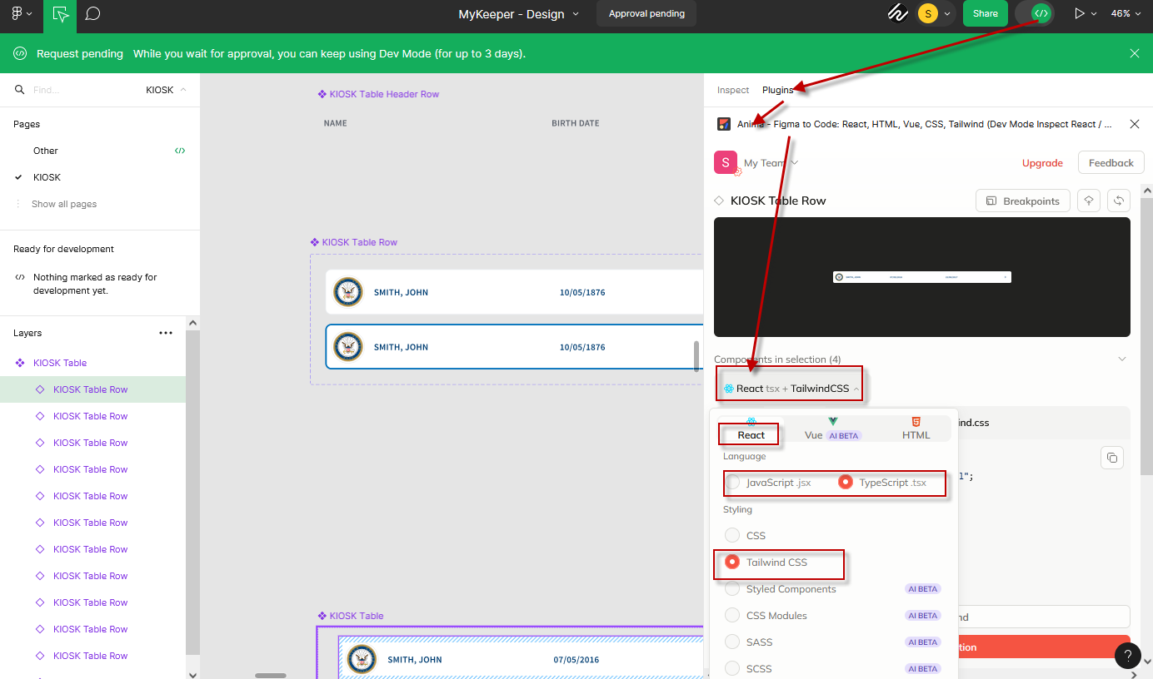

2. Convert Figma object style to tailwind classes.

Case A: Convert to Built-in tainwind class,

when style Property value match tailwind class property value.

If Anima detect a style property value match a tailwind class property value, it will auto convert it to related tailwind class. For example, if the object height is set to 36px on figma, it will be converted to tailwind class “h-9” as below.

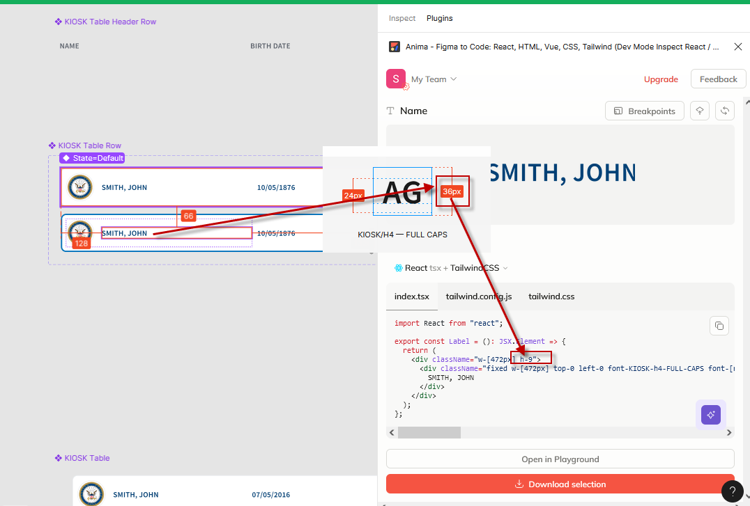

Case B: Generate to new user defined tailwind valuables and classes ,

when there is no matching built-in tailwind class found, or a figma valuable is used.

The user defined tailwind classes and config will be auto generated on tailwind.config.js and tailwind.css

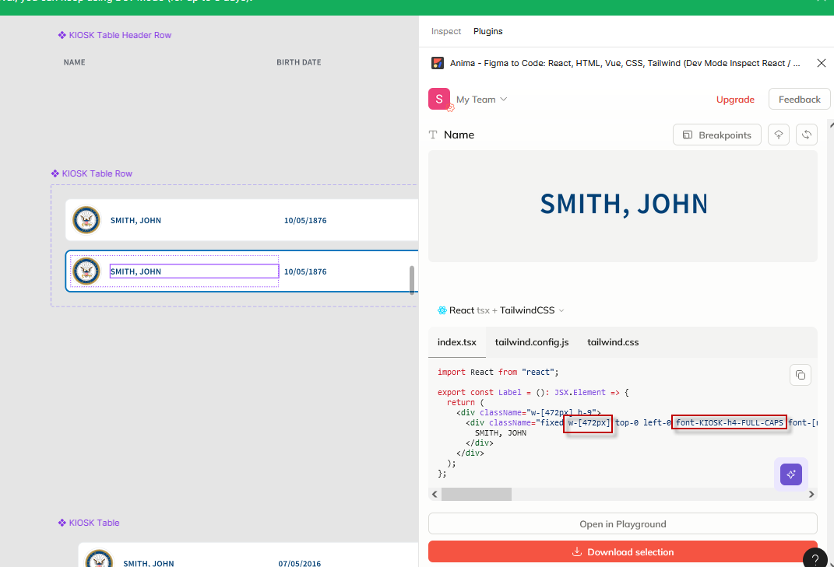

3. Download and open the generated react+tailwind app project.

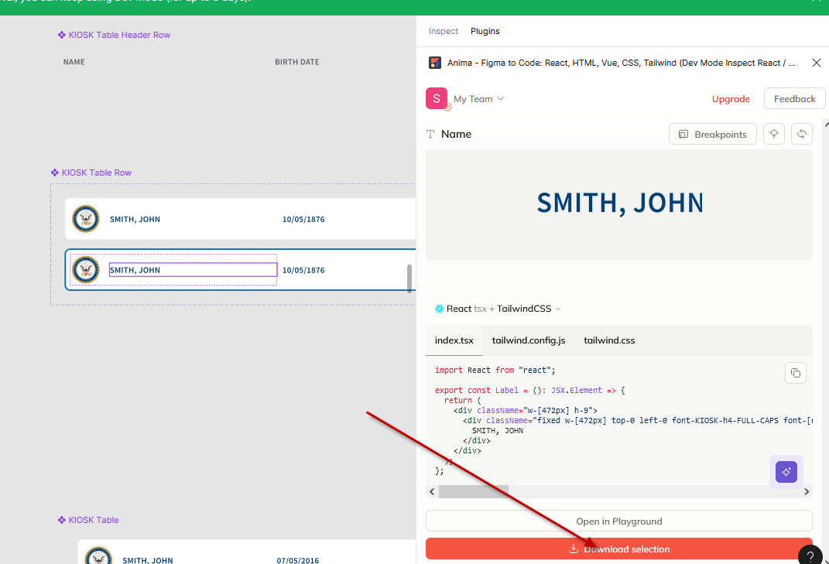

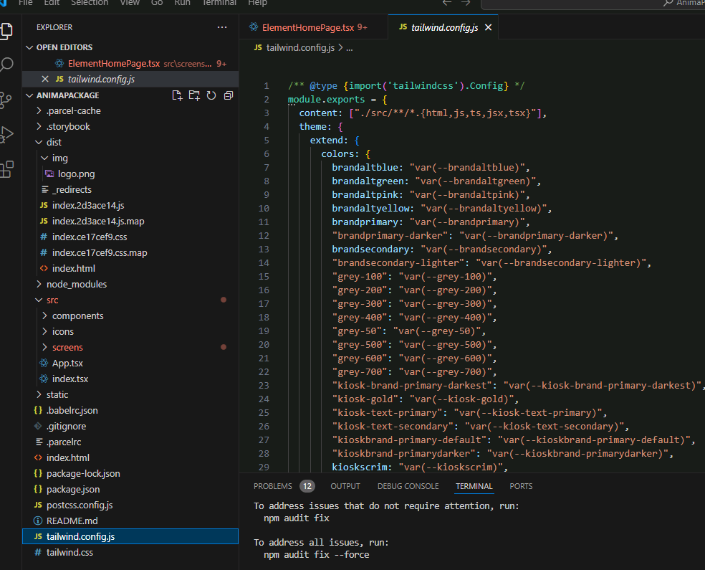

4. Use the code as reference, create related page/component in our own nextjs app.

4.1 Merge the generated tailwind.config.js to nextjs tawilwind.config.js

4.2 Merge the generated tailwind.css, which contains all the generate valuables/parameters to nextjs app main style file.

4.3 Merge generated images in /img/ folder to nextjs app

4.4 Create NextJs page or component reference to the generated react codes.

It’s most time consuming part, need to read the original long codes of pages and components, rewrite the codes to make it simpler with nextjs, make responsible, and etc.

The generated codes is much more “long” than human written code, and it’s not responsive. Need to reduce the code and make it responsive while keep the layout base position, size color, and font.

The generated components can also be reduced. (It generated a lot of unnecessary components).

